
Migration Testing Protocol

Presented to:
<CLIENT NAME>
2/9/2021

Cognizant Microsoft Business Group
20 North Wacker Drive #530
Chicago, IL 60606

Notice of Confidentiality ©2021 Cognizant Microsoft Business Group All rights reserved.

IS SUBJECT TO THE TERMS OF THE COGNIZANT MICROSOFT BUSINESS GROUP NON-DISCLOSURE AGREEMENT. NEITHER THIS DOCUMENT NOR ITS CONTENTS MAY BE REVEALED OR DISCLOSED TO UNAUTHORIZED PERSONS OR SENT OUTSIDE THE AFOREMENTIONED COMPANY WITHOUT PRIOR PERMISSION FROM COGNIZANT
MICROSOFT BUSINESS GROUP.
Table of Contents
Summary 3
Failover Testing 4
Failover Testing Procedure 5
Failover Testing Checklist 5
Infrastructure Testing 6
Infrastructure Testing Procedure 6
Infrastructure Testing Checklist 6
Application Testing 7
Application Testing Procedure 7
Application Testing Checklist 7
Rollback 8
Rollback Procedure 8

Summary
This document Is Intended to provide high-level guidance for testing before and after rehosting of a server or workload to Azure. It Is Important to perform testing on workloads moving to the cloud to verify:
- Migration tooling functionality
- Proper bandwidth and network connectivity
- Verify right sizing to ensure acceptable performance level Is still being achieved In Azure
- Verify any established benchmarks are being met In Azure
- Verify no compatibility Issues exist that may have been unaccounted for previously
There are three types of testing that should be performed during the migration lifecycle:
- Failover testing - this testing takes place before migration to ensure the failover to Azure happens with as little Interruption In service as possible. This could be as short as verifying the VM boots, to as much as fully testing an application In an Isolated environment In Azure.
- Virtual infrastructure testing - this testing takes place after failover and ensures the VMs and Azure virtual Infrastructure are all configured and performing as expected.
- Application testing - this testing will be performed by the client application teams that understand the workload that has been migrated. This testing should be a full QA test of the workload to ensure that It Is performing as expected and suitable to continue as production.

Workload Migration Lifecycle

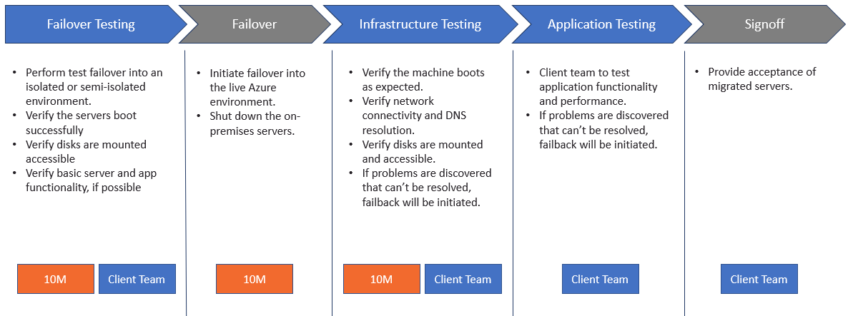

Failover Testing
Failover testing should take place before migrating into a live production Azure environment. During failover testing, VMs are brought online from the replicated server or workload data that has been copied to Azure storage. The VMs are created and brought online In an Isolated or semi-Isolated environment while the production on-premises source VMs are left online. Since the on-premises machines are online during this testing, It Is Important that the landing network Is Isolated to prevent Active Directory trust conflicts, testing server registration into production DNS, unwanted communication to production resources, etc.
A typical Isolated testing environment would consist of a VNET that Is peered to your hub network, a failover testing VNET and subnet, an NSG that Isolates all but necessary traffic (such as RDP), and jump box If desired.

Typical Failover Testing Topology

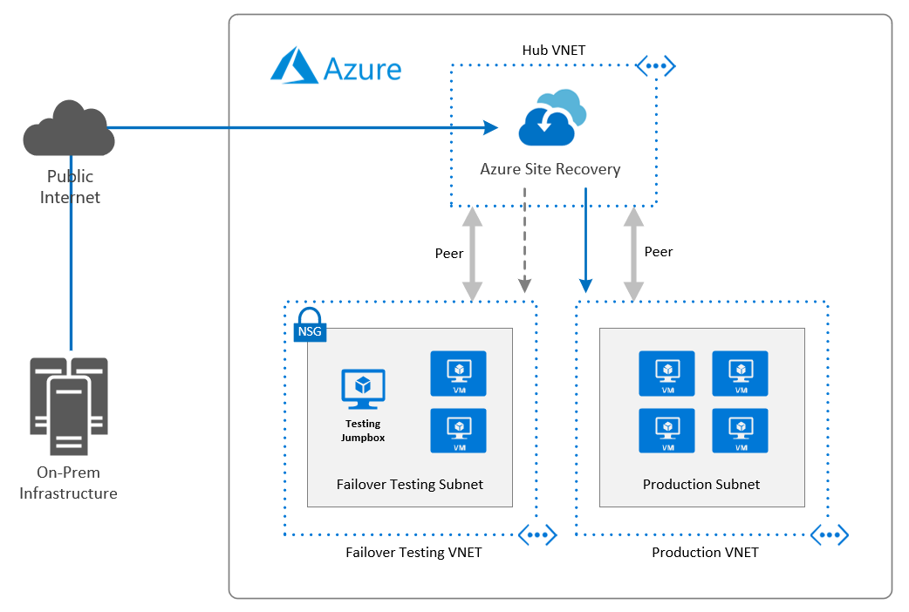

Failover Testing Procedure

Failover testing should be a collaborative effort between MBG and the client team. After the source workloads have been replicated and are in sync to the desired RPO, MBG will Initiate the test failover via Azure Site Recovery or Azure Migrate and provide basic testing, as level of granted access allows.
Client infrastructure and application teams should participate and test as much as possible. If application testing Is possible, it is highly recommended.

Failover Testing Checklist

☐ | Does the server boot as expected to the login screen? This can be checked via boot diagnostics?
☐ | Did the server boot normally within the typical boot time without any new errors?
☐ | Is the server accessible over the network?
☐ | Is there any new latency experienced that is not acceptable?
☐ | Can you log into the server as expected? During failover testing it may only be possible to test local logins due to the NSG blocking communication to an Active Directory.
☐ | Are any new errors being reported in the system or application logs that may indicate a problem?
☐ | Are disks mounted, appear to be at RPO, and in a healthy state?
☐ | If possible, test disk performance to ensure deployed level of performance is acceptable.
☐ | Are any services in a failed state that should be running? Will they start normally?
☐ | If any services failed on first boot, do they start normally on following reboots?
☐ | Are any new errors being reported in the system or application logs that may indicate a problem?
☐ | If possible, test server or application performance against a benchmark. Should resizing be considered?

Infrastructure Testing
Infrastructure testing should take place after failover testing has been completed and any problems or concerns that were discovered have been resolved. During failover, Azure VMs are brought online from the replicated server or workload data that has been copied to Azure storage. The VMs are created and brought online in the production Azure environment and the production on-premises source VMs are shut down.
After failover, the Azure machines should be considered as production, and tested accordingly. It Is critical that Infrastructure and application testing are thorough to ensure that any problems are discovered and are resolved as quickly as possible.

Infrastructure Testing Procedure

Infrastructure testing should be a collaborative effort between MBG and the client team. After the source workloads have been replicated and are in sync to the desired RPO and failover testing Is complete, MBG will Initiate the failover via Azure Site Recovery or Azure Migrate during the designated window and provide basic testing, as level of granted access allows.
Client infrastructure teams should participate and test as much as possible.

Infrastructure Testing Checklist

☐ | Does the server boot as expected to the login screen? This can be checked via boot diagnostics?
☐ | Did the server boot normally within the typical boot time without any new errors?
☐ | Is the server accessible over the network?
☐ | Are DNS lookups resolving the new Azure IP as expected?
☐ | Is there any new latency experienced that is not acceptable?
☐ | Can you log into the server as expected?
☐ | Are any new errors being reported in the system or application logs that may indicate a problem?
☐ | Are disks mounted, appear to be at RPO, and in a healthy state?
☐ | If possible, test disk performance to ensure deployed level of performance is acceptable.
☐ | Are any services in a failed state that should be running? Will they start normally?
☐ | If any services failed on first boot, do they start normally on following reboots?
☐ | Are any new errors being reported in the system or application logs that may indicate a problem?
☐ | Test server performance against a benchmark. Should resizing be considered?

Application Testing
Application testing should be performed after failover and Infrastructure testing has passed validation. Application testing should be performed by the client team that Is responsible for the workload or applications that are being migrated. Since this workload Is now considered production, we recommend that you perform any QA, benchmark, or load testing that would normally be performed after maintenance to ensure the application Is performing as expected In Azure.

Application Testing Procedure

The application testing procedure should be defined by the client teams. This procedure should be a based on any QA, benchmark, or load testing used in standard QA testing, maintenance, or upgrade testing. We suggest that you develop and have this process well documented, planned, and staffed before the migration.

Application Testing Checklist

Since application testing is performed by the client team that understands the workload, we can only provide a very basic checklist. We suggest that you develop and have this process well documented before the migration.

☐ | Did the applications start as expected?
☐ | If applications did not start as expected, do they start after a reboot of the workload servers in the correct order?
☐ | Are databases used by the workload accessible and performing as expected?
☐ | Is there any new network latency introduced after the migration that is affecting performance of the application or parts of the application? Is it acceptable?
☐ | Is the workload accessible from the expected URL or endpoint?
☐ | Are end users able to access and login to the application and interact with it as they normally would?
☐ | Are the application performance meeting predefined benchmarks and/or end user expectations?
☐ | Are any new errors being reported in the system or application logs that may indicate a new problem?
☐ | If possible, test disk performance to ensure deployed level of performance is acceptable.
☐ | Test application performance against a benchmark. Should resizing of any virtual machines be considered?

Rollback
At times, unforeseen problems arise that may require a migration to be rolled back. Using Azure Site Recovery or Azure Migrate makes this process simple and It can be performed quickly to minimize downtime.

Rollback Procedure

During testing, if a problem is discovered that cannot be resolved, or cannot be resolved in the designated failover window, the migration or the workload, or parts of the workload will be marked as failed and a rollback will be initiated. This will be a collaborative effort that will Involve both Azure and on-prem resources and will require team resources with access to perform the activities. It Is the responsibility of the testers to call out any failures in a timely fashion so they can be discussed, and a go / no-go decision can be made by the proper party.

 | Action | Responsible Party
☐ | Stop the VMs targeted for rollback in Azure. | MBG
☐ | Start the source VMs on-premises. | Client Team
☐ | Reverse any DNS changes made during the migration. | Client Team
☐ | Verify login to the VM and that Active Directory trust has not been broken (Windows) | Client Team
☐ | Perform infrastructure testing on the on-premise VMs to verify they are back up and functioning as expected. | Client Team
☐ | Verify end users can access the servers and applications that have been rolled back and interact with them normally. | Client Team
☐ | Disable and restart replication of the VMs to re-establish sync. | MBG
☐ | Gather all details of the problem that forced the rollback and schedule a planning session to determine remediation steps and how to proceed. | MBG

